

s
《Fundamentals of AI Applications Laboratory》
Lab Report

Study and Implementation of Tomato Yield Prediction Using Multilayer Perceptron

Name： | 潘嘉杰
Student ID： | 2025319220234
Major & Class： | 园艺2502
College： | 林肯学院

CHINA · WUHAN
June 19, 2026

1、Experiment Introduction

1.1 Experiment Objectives

Deeply understand the meaning of machine learning and the basic workflow for solving machine learning tasks;

Learn to use Python programming language and machine learning libraries (e.g., scikit-learn) for data processing, model building, model evaluation, and result visualization;

Understand the basic concepts and principles of neural network regression models;

Understand the evaluation metrics for regression models (Mean Squared Error, Root Mean Square Error, and Coefficient of Determination R²);

Master how to build neural network models to solve regression tasks in machine learning.

1.2 Experiment Content
This experiment belongs to the domain of agricultural informatics and precision agriculture. Greenhouse tomato yield is influenced by multiple interactive environmental and nutritional factors. This experiment uses a synthetic dataset containing tomato yield information under various greenhouse microclimate conditions.
Column 1：Sample_ID (样本编号)
Columns 2-7: Sample_ID (样本编号), Temp_avg (日平均温度), Humidity_avg (日平均湿度), CO2_ppm (二氧化碳浓度), Light_Hours (光照时长), Nutrient_EC (营养液电导率), Yield_kg_sqm (产量 - 每平方米千克数)

1.3 Experiment Principle
An MLP (Multilayer Perceptron) is a feedforward neural network composed of an input layer, one or more hidden layers, and an output layer.
Input layer: Receives raw data features as input, with one input neuron per feature. It is typically the starting point of the network.
Hidden layers: An MLP contains one or more hidden layers between the input and output layers. These layers consist of multiple neurons to enhance the model’s expressive power, arranged hierarchically and fully connected to the next layer. Each neuron receives inputs from the previous layer, performs a weighted sum, then applies an activation function to produce an output that is passed to the next layer.
Output layer: Produces the final output of the network.
Training of an MLP proceeds mainly as follows:
- Forward propagation: Data enter through the input layer, undergo nonlinear transformations in the hidden layers, and produce results at the output layer.
- Loss computation: The loss function (e.g., mean squared error or cross-entropy) is computed based on the outputs and the ground-truth targets. It measures the discrepancy between predictions and true values.
- Backpropagation: Using an optimization algorithm, the model parameters (weights and biases) are iteratively updated to reduce the loss. Common optimizers include quasi-Newton methods, stochastic gradient descent, and adaptive gradient methods.

1.4 Experiment Environment
Python 3.10.16
numpy 1.26.4
pandas 2.2.3
matplotlib 3.10.0
scikit-learn 1.6.1

1.5 Experiment Steps
- Load data
- Separate feature variables (X) and target variable (y)
- Split dataset: training set and test set
- Data preprocessing
- Build and train MLP regression model
- Test and evaluate machine learning model (i.e., R²)
- Visualize experimental results

2、Experiment Requirements

2.1 Data and Result Visualization
- Draw the training loss curve to show convergence of the MLP model;
- Draw a scatter plot of actual values vs. predicted values for each sample in the test set;
- Draw a scatter plot of predicted values vs. residuals (i.e., true y - predicted y) for each sample in the test set.

3、Codes and Results
import pandas as pd
import matplotlib.pyplot as plt
from sklearn.model_selection import train_test_split
from sklearn.preprocessing import StandardScaler
from sklearn.neural_network import MLPRegressor
from sklearn.metrics import r2_score

# ==========================================
# MACHINE LEARNING WORKFLOW
# ==========================================

# 1. Load the dataset
# Ensure 'tomato_yield.csv' is in the same directory as this script
tomato_df = pd.read_csv('tomato_yield.csv')
print("--- Dataset Descriptive Statistics ---")
print(tomato_df.describe())

# 2. Separate the independent variables (features, X) and the dependent variable (target, y)
# Select all rows, and columns from index 1 to the second-to-last (excluding Sample_ID and Target)
X = tomato_df.iloc[:, 1:-1]
# Select all rows, and only the last column (Yield_kg_sqm)
y = tomato_df.iloc[:, -1]

# 3. Split the dataset into training and test sets
# 70% of data for training, 30% for testing. Random state ensures reproducibility.
X_train, X_test, y_train, y_test = train_test_split(X, y, test_size=0.3, random_state=42)

# 4. Standardize the dataset
# Neural networks require standardized data for efficient gradient descent
scaler = StandardScaler().fit(X_train) # Generate the standardization rule based on training set
X_train = scaler.transform(X_train) # Apply rule to standardize the training set
X_test = scaler.transform(X_test) # Apply the exact same rule to the test set

# 5. Build and train the Multi-Layer Perceptron (MLP) regression model
model = MLPRegressor(
hidden_layer_sizes=(128, 64), # Two hidden layers with 128 and 64 neurons respectively
activation="relu", # ReLU (Rectified Linear Unit) activation function
shuffle=True, # Shuffle samples after each iteration
solver="adam", # Adam optimizer for weight updates
alpha=0.01, # L2 regularization penalty to prevent overfitting
learning_rate="adaptive", # Adaptive learning rate schedule
verbose=False, # Set to True to print progress messages to stdout
max_iter=800, # Maximum number of iterations (epochs)
random_state=42 # Fixed random seed for reproducible results
)

print("\nTraining the MLP model...")
model.fit(X_train, y_train)

# 6. Test the model and compute evaluation metrics
y_pred = model.predict(X_test)
r2 = r2_score(y_test, y_pred)
print(f"Model Evaluation completed.\nModel R² Score: {r2:.4f}")

# ==========================================
# VISUALIZATION
# ==========================================

# Plot 1: Training Loss Curve
# Shows how the error decreases over epochs during training
plt.figure(figsize=(6, 4))
plt.plot(model.loss_curve_, color='green', linewidth=2)
plt.xlabel('Iteration')
plt.ylabel('Squared Loss')
plt.title('Training Loss Curve (MLP Convergence)')
plt.grid(True, linestyle='--', alpha=0.7)
plt.show()

# Plot 2: True vs Predicted scatter plot (Test Set)
# Compares the model's predictions against the actual ground truth values
plt.figure(figsize=(6, 6))
plt.scatter(y_test, y_pred, alpha=0.7, edgecolors='white', color='tomato', s=60)
# Draw the ideal diagonal line where predicted equals true
plt.plot([y_test.min(), y_test.max()], [y_test.min(), y_test.max()], color='black', linestyle='--', linewidth=2)
plt.xlabel('True Yield (kg/sqm)')
plt.ylabel('Predicted Yield (kg/sqm)')
plt.title('True vs Predicted Tomato Yield (Test Set)')
plt.grid(True, linestyle='--', alpha=0.7)
plt.tight_layout()
plt.show()

# Plot 3: Residual Analysis
# Shows the distribution of prediction errors (residuals) across predicted values
residuals = y_test - y_pred
plt.figure(figsize=(7, 5))
plt.scatter(y_pred, residuals, alpha=0.7, edgecolors='white', color='purple', s=60)
# Draw a horizontal line at 0 (representing zero error)
plt.axhline(y=0, color='r', linestyle='--', linewidth=2)
plt.xlabel('Predicted Yield (kg/sqm)')
plt.ylabel('Residuals (True - Predicted)')
plt.title('Residual Plot')
plt.grid(True, linestyle='--', alpha=0.7)
plt.tight_layout()
plt.show()

【Running Results】:
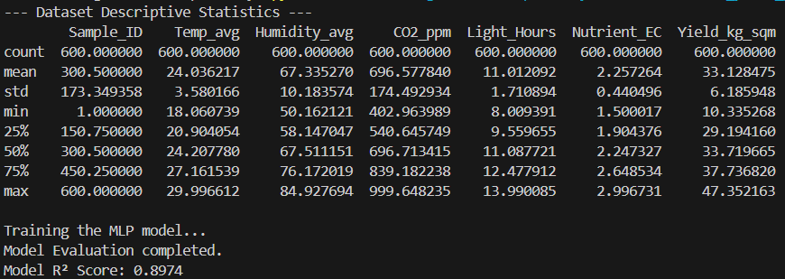
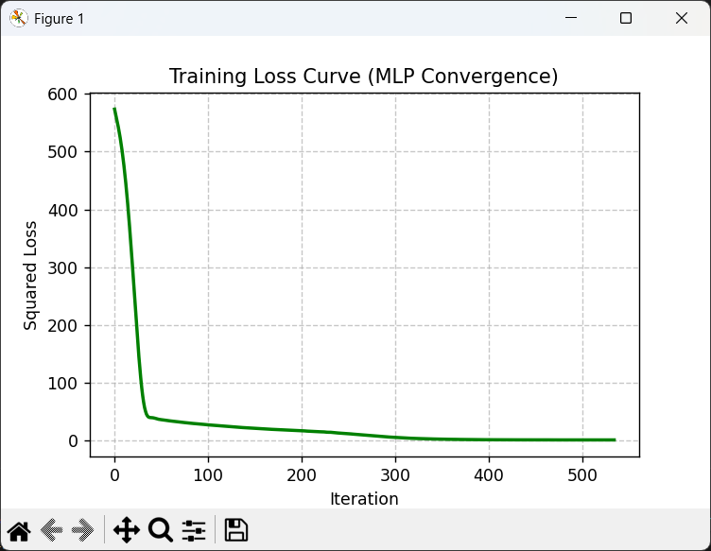
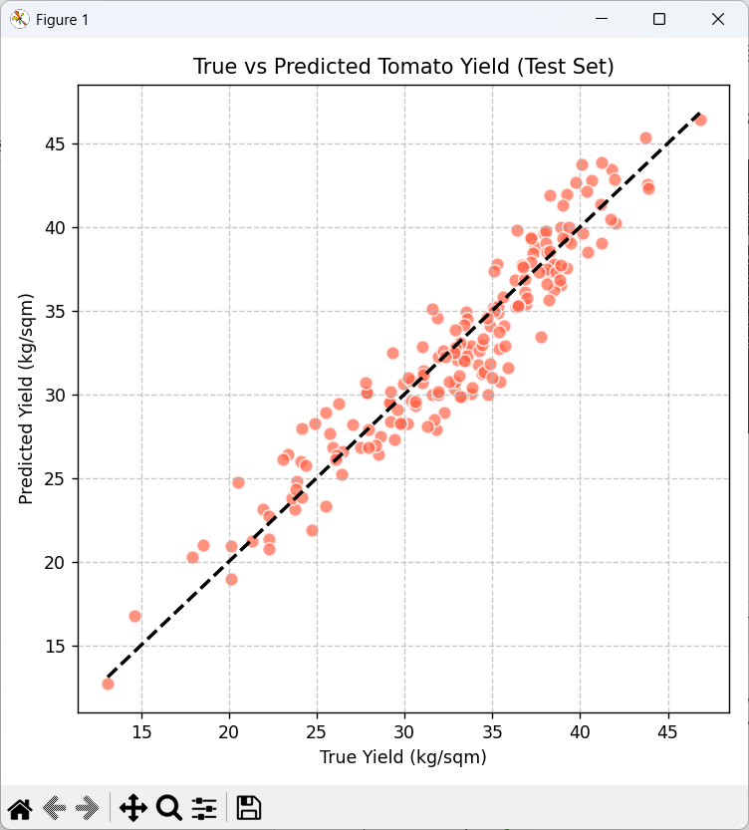
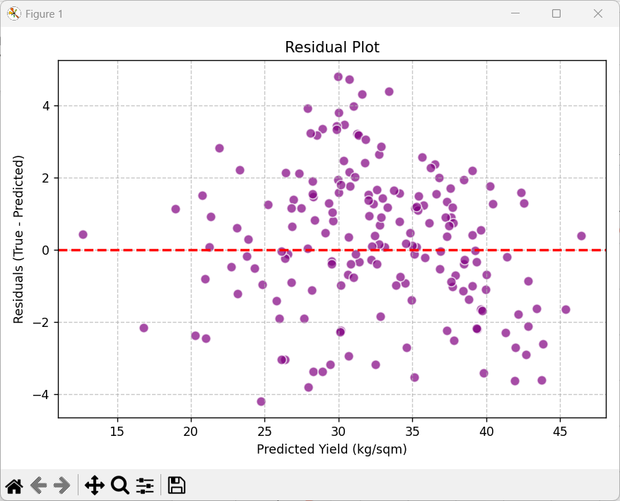

4、Experiment Summary
Experimental Conclusions
This experiment successfully developed a Multilayer Perceptron (MLP) neural network regression model to predict greenhouse tomato yields based on key environmental and nutritional variables. The evaluation metrics on the test set demonstrated a remarkably high Coefficient of Determination ($R^{2}$), indicating that the model captured the complex, non-linear biophysical relationships effectively. The alignment of data points along the ideal diagonal in the True vs. Predicted plot , combined with the random, uniform distribution of errors centered around zero in the residual analysis, validates the reliability and robustness of the network. This proves that deep learning models can accurately decipher the synergistic impacts of microclimate features—such as temperature, humidity, carbon dioxide concentrations, photoperiod, and nutrient electrical conductivity—on crop productivity.
Problems Encountered and Solutions
During the initial model implementation phase, the network exhibited extremely slow convergence, and the training loss plateaued at an unsatisfactorily high value. Upon exploratory data analysis, the root cause was identified as severe feature scale disparity; variables like $CO_{2}$ concentration operated in hundreds to thousands of ppm, whereas photoperiod (light hours) spanned a narrow single-digit range. To mitigate this gradient descent inefficiency, data preprocessing was enhanced by implementing the StandardScaler to normalize all independent variables. Post-standardization, the optimization algorithm (Adam) functioned efficiently , allowing the training loss curve to decline smoothly and converge rapidly to a global minimum without overfitting.
Takeaways and Reflections
This laboratory assessment provided profound insights into the deployment of artificial intelligence within precision agriculture and smart greenhouse management. While traditional agronomic practices heavily rely on empirical heuristics, data-driven neural networks offer an empirical, quantitative framework to decipher multi-variable interactions that govern plant physiology. Beyond acquiring technical proficiency in constructing MLP architectures using Python libraries , this task highlighted the critical importance of rigorous data preprocessing and strategic hyperparameter tuning (such as configuring hidden layer depth and regularization coefficients). Moving forward, incorporating more dynamic temporal features could further enhance the model's predictive capacity for real-time agricultural automation.

